**Benefits Of:**

**Platform-as-a-Service(PaaS):**

Platform as a service (PaaS) is a complete development and deployment environment in the cloud, with resources that enable you to deliver everything from simple cloud-based apps to sophisticated, cloud-enabled enterprise applications. You purchase the resources you need from a cloud service provider on a pay-as-you-go basis and access them over a secure Internet connection.

Like IaaS, PaaS includes infrastructure—servers, storage, and networking—but also middleware, development tools, business intelligence (BI) services, database management systems, and more. PaaS is designed to support the complete web application lifecycle: building, testing, deploying, managing, and updating.

PaaS allows you to avoid the expense and complexity of buying and managing software licenses, the underlying application infrastructure and middleware, container orchestrators such as Kubernetes, or the development tools and other resources. You manage the applications and services you develop, and the cloud service provider typically manages everything else.

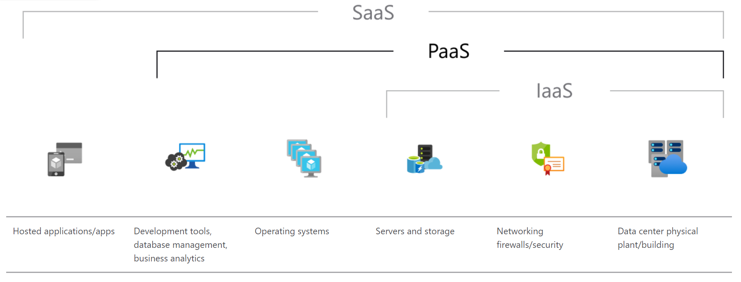

**Advantages of PaaS:**

By delivering infrastructure as a service, PaaS offers the same advantages as IaaS. But its additional features—middleware, development tools, and other business tools—give you more advantages:

**Cut coding time:** PaaS development tools can cut the time it takes to code new apps with pre-coded application components built into the platform, such as workflow, directory services, security features, search, and so on.

**Add development capabilities without adding staff:** Platform as a Service components can give your development team new capabilities without needing to add staff having the required skills.

**Develop for multiple platforms—including mobile—more easily:** Some service providers give you development options for multiple platforms, such as computers, mobile devices, and browsers making cross-platform apps quicker and easier to develop.

**Use sophisticated tools affordably:** A pay-as-you-go model makes it possible for individuals or organizations to use sophisticated development software and business intelligence and analytics tools that they could not afford to purchase outright.

**Support geographically distributed development teams:** Because the development environment is accessed over the Internet, development teams can work together on projects even when team members are in remote locations.

**Efficiently manage the application lifecycle:** PaaS provides all of the capabilities that you need to support the complete web application lifecycle: building, testing, deploying, managing, and updating within the same integrated environment.

**Information-as-a-Service(IaaS):**

Infrastructure as a service (IaaS) is a type of cloud computing service that offers essential compute, storage, and networking resources on demand, on a pay-as-you-go basis. IaaS is one of the four types of cloud services, along with software as a service (SaaS), platform as a service (PaaS), and serverless.

Migrating your organization's infrastructure to an IaaS solution helps you reduce maintenance of on-premises data centers, save money on hardware costs, and gain real-time business insights. IaaS solutions give you the flexibility to scale your IT resources up and down with demand. They also help you quickly provision new applications and increase the reliability of your underlying infrastructure.

IaaS lets you bypass the cost and complexity of buying and managing physical servers and data center infrastructure. Each resource is offered as a separate service component, and you only pay for a particular resource for as long as you need it. A cloud computing service provider like Azure manages the infrastructure, while you purchase, install, configure, and manage your own software—including operating systems, middleware, and applications.

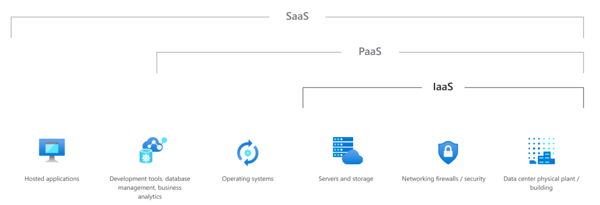

**Advantages of IaaS:**

**Reduces capital expenditures and optimizes costs**

IaaS eliminates the cost of configuring and managing a physical datacenter, which makes it a cost-effective choice for migrating to the cloud. The pay-as-you-go subscription models used by IaaS providers help you reduce hardware costs and maintenance and enable your IT team to focus on core business.

**Increases scale and performance of IT workloads**

IaaS lets you scale globally and accommodate spikes in resource demand. That way, you can deliver IT resources to employees from anywhere in the world faster and enhance application performance.

**Increases stability, reliability, and supportability**

With IaaS, there's no need to maintain and upgrade software and hardware or troubleshoot equipment problems. With the appropriate agreement in place, the service provider assures that your infrastructure is reliable and meets service-level agreements (SLAs).

**Improves business continuity and disaster recovery**

Achieving high availability, business continuity, and disaster recovery is expensive because it requires a significant amount of technology and staff. But with the right SLA in place, IaaS helps to reduce this cost. It also helps you access applications and data as usual during a disaster or outage.

**Enhances security**

With the appropriate service agreement, a cloud service provider can offer better security for your applications and data than the security you would attain in house.

**Helps you innovate and get new apps to users faster**

With IaaS, once you've decided to launch a new product or initiative, the necessary computing infrastructure can be ready in minutes or hours, rather than in days or weeks. And because you don't need to set up the underlying infrastructure, IaaS lets you deliver your apps to users faster.

**Software-as-a-Service(SaaS):**

Software as a service (SaaS) allows users to connect to and use cloud-based apps over the Internet. Common examples are email, calendaring, and office tools.

SaaS provides a complete software solution that you purchase on a pay-as-you-go basis from a cloud service provider. You rent the use of an app for your organization, and your users connect to it over the Internet, usually with a web browser. All of the underlying infrastructure, middleware, app software, and app data are located in the service provider’s data center. The service provider manages the hardware and software, and with the appropriate service agreement, will ensure the availability and the security of the app and your data as well. SaaS allows your organization to get quickly up and running with an app at minimal upfront cost.

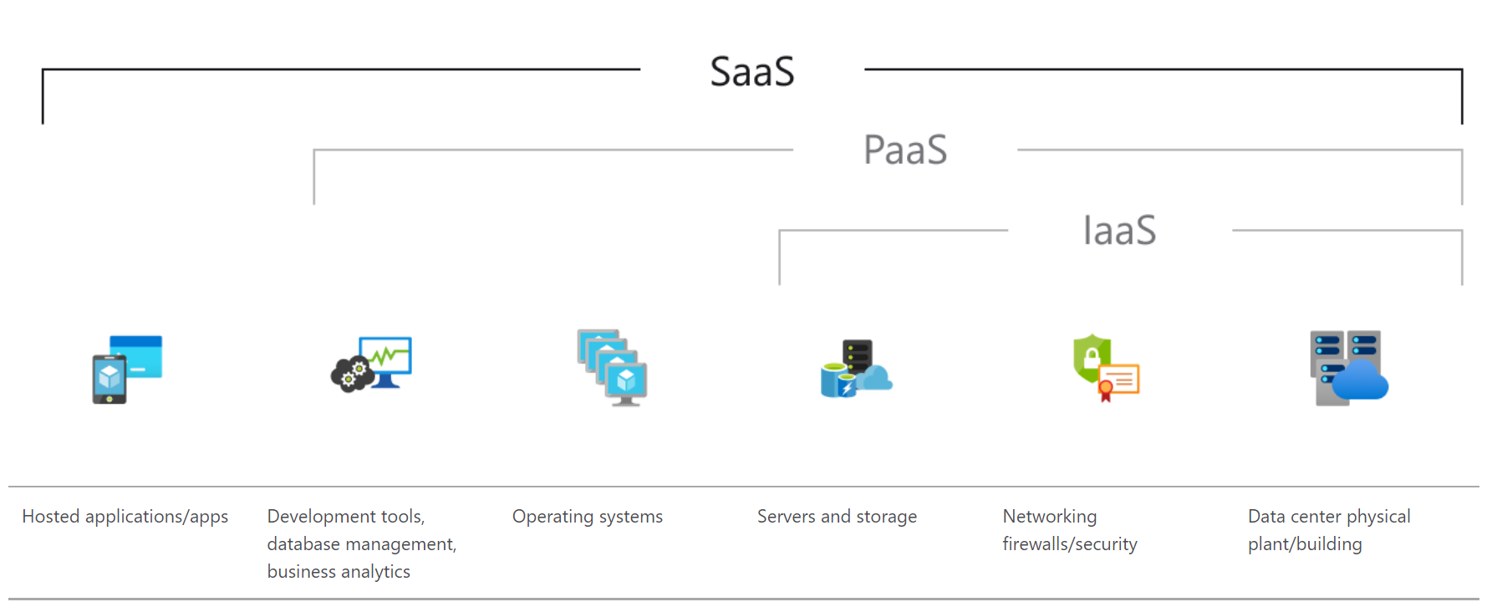

**Advantages of SaaS:**

**Gain access to sophisticated applications:** To provide SaaS apps to users, you don’t need to purchase, install, update, or maintain any hardware, middleware, or software. SaaS makes even sophisticated enterprise applications, such as ERP and CRM, affordable for organizations that lack the resources to buy, deploy, and manage the required infrastructure and software themselves.

**Pay only for what you use:** You also save money because the SaaS service automatically scales up and down according to the level of usage.

**Use free client software:** Users can run most SaaS apps directly from their web browser without needing to download and install any software, although some apps require plugins. This means that you don’t need to purchase and install special software for your users.

**Mobilize your workforce easily:** SaaS makes it easy to “mobilize” your workforce because users can access SaaS apps and data from any Internet-connected computer or mobile device. You don’t need to worry about developing apps to run on different types of computers and devices because the service provider has already done so. In addition, you don’t need to bring special expertise onboard to manage the security issues inherent in mobile computing. A carefully chosen service provider will ensure the security of your data, regardless of the type of device consuming it.

**Access app data from anywhere:** With data stored in the cloud, users can access their information from any Internet-connected computer or mobile device. And when app data is stored in the cloud, no data is lost if a user’s computer or device fails.

**Write Short Notes on:**

**SOAP message**

SOAP is an XML-based protocol for accessing web services over HTTP. It has some specifications which could be used across all applications.

SOAP is known as the Simple Object Access Protocol, but in later times was just shortened to SOAP v1.2. SOAP is a protocol or in other words is a definition of how web services talk to each other or talk to client applications that invoke them.

SOAP was developed as an intermediate language so that applications built on various programming languages could talk easily to each other and avoid the extreme development effort.

**Advantages:**

* When developing SOAP based Web services, you need to have some language which can be used for web services to talk with client applications. SOAP is the perfect medium which was developed in order to achieve this purpose. This protocol is also recommended by the W3C consortium which is the governing body for all web standards.
* SOAP is a light-weight protocol that is used for data interchange between applications. Note the keyword ‘**light**.’ SOAP programming is based on the XML language, which itself is a lightweight data interchange language, hence SOAP as a protocol that also falls in the same category.
* SOAP is designed to be platform independent and is also designed to be operating system independent. So the SOAP protocol can work with any programming language based applications on both Windows and Linux platforms.
* It works on the HTTP protocol –SOAP works on the HTTP protocol, which is the default protocol used by all web applications. Hence, there is no sort of customization which is required to run the web services built on the SOAP protocol to work on the World Wide Web.

**FOR MORE STUDY MATERIALS PLEASE REFER TO THE LINK:**

→ [SOAP Web Services Tutorial: What is SOAP Protocol? EXAMPLE (guru99.com)](https://www.guru99.com/soap-simple-object-access-protocol.html)

**Amazon Web Services(AWS)**

Amazon web service is an online platform that provides scalable and cost-effective cloud computing solutions.

AWS is a broadly adopted cloud platform that offers several on-demand operations like compute power, database storage, content delivery, etc., to help corporations scale and grow.

## Applications of AWS

AWS enables businesses to build a number of sophisticated applications. Organizations of every industry and of every size, can run every imaginable use case on AWS. Here are some of the most common applications of AWS:-

### **1. Storage and Backup**

One of the reasons why many businesses use AWS is because it offers multiple types of storage to choose from and is easily accessible as well. It can be used for storage and file indexing as well as to run critical business applications.

### **2. Websites**

Businesses can host their websites on the AWS cloud, similar to other web applications.

### **3. Gaming**

There is a lot of computing power needed to run gaming applications. AWS makes it easier to provide the best online gaming experience to gamers across the world.

### **4. Mobile, Web and Social Applications**

A feature that separates AWS from other cloud services is its capability to launch and scale mobile, e-commerce, and SaaS applications. API-driven code on AWS can enable companies to build uncompromisingly scalable applications without requiring any OS and other systems.

## **Advantages of AWS Services**

The power of AWS services lies in the fact that it enables businesses to reach the marketplaces with little initial investment. Here are some advantages of AWS services:

### **1. Security**

There is a false misconception that data stored in a public cloud is not secure. On the contrary, not only does AWS offer security tools that are cheaper than other alternatives, but it is one of the most secure, extensive, and reliable cloud platforms.

### **2. Global Availability**

AWS has 80 Availability Zones across 25 geographic regions global data centers.

### **2. Scalability and Flexibility**

AWS offers unlimited flexibility and scalability on demand. This enables organizations to plan their infrastructure roadmap on a subscription basis without full commitment.

### **3. Little Investment**

AWS cloud services enable companies to save expenditures on extra software and hardware. There is no physical data required, which ultimately lowers down operating costs.

## **AWS Services**

Amazon has many services for cloud applications. Let us list down a few key services of the AWS ecosystem and a brief description of how developers use them in their business.

Amazon has a list of services:

1. Compute service
   * AWS EC2
   * AWS Lambda
2. Storage
   * Amazon S3
   * Amazon EBS
3. Database
   * DynamoDB
   * RDS
4. Networking and delivery of content
   * VPC
   * Route 53
5. Security tools
   * Identity Access Management (IAM)
   * KMS
6. Developer tools
   * CodeStar
   * Code Build
7. Management tools
   * Cloud Watch
   * Cloud Formation

For more Resources: → [What Is AWS(Amazon Web Services): Services and Applications [Updated] | Simplilearn](https://www.simplilearn.com/tutorials/aws-tutorial/what-is-aws)

**XEN Virtualization:**

**Xen** is an open source hypervisor based on paravirtualization. It is the most popular application of paravirtualization. Xen has been extended to be compatible with full virtualization using hardware-assisted virtualization. It enables high performance to execute guest operating systems. This is probably done by removing the performance loss while executing the instructions requiring significant handling and by modifying portions of the guest operating system executed by Xen, with reference to the execution of such instructions. Hence this especially supports x86, which is the most used architecture on commodity machines and services.

Pros:

a) Xen server is developed over open-source Xen hypervisor and it uses a combination of hardware-based virtualization and paravirtualization. This tightly coupled collaboration between the operating system and virtualized platform enables the system to develop lighter and flexible hypervisors that deliver their functionalities in an optimized manner.

b) Xen supports balancing of large workloads efficiently that capture CPU, Memory, disk input-output and network input-output of data. It offers two modes to handle this workload: Performance enhancement, and For handling data density.

c) It also comes equipped with a special storage feature that we call Citrix storage link. Which allows a system administrator to use the features of arrays from Giant companies- Hp, Netapp, Dell Equal logic etc.

d) It also supports multiple processors, Iive migration from one machine to another, physical server to virtual machine or virtual server to virtual machine conversion tools, centralized multi server management, real time performance monitoring over windows and linux.

Cons:

a) Xen is more reliable over linux rather than on windows.

b) Xen relies on 3rd-party components to manage the resources like drivers, storage, backup, recovery & fault tolerance.

c) Xen deployment could be a burden on your Linux kernel system as time passes.

d) Xen sometimes may cause an increase in load on your resources by high input-output rate and may cause starvation of other Vm’s Servers.

**Amazon EC2(Amazon Elastic Computing Cloud):**

Amazon Elastic Compute Cloud (Amazon EC2) is a web-based service that allows businesses to run application programs in the Amazon Web Services (AWS) public cloud. Amazon EC2 allows a developer to spin up virtual machines (VMs), which provide compute capacity for IT projects and cloud workloads that run with global AWS data centers.

An AWS user can increase or decrease instance capacity as needed within minutes using the Amazon EC2 web interface or an application programming interface (API). A developer can code an application to scale instances automatically with AWS Auto Scaling. A developer can also define an autoscaling policy and group to manage multiple instances at once.

### **How EC2 work?**

To begin using EC2, developers sign up for an account at Amazon's AWS website. They can then use the AWS Management Console, the AWS Command Line Tools (CLI), or AWS Software Developer Kits (SDKs) to manage EC2.

A developer then chooses EC2 from the AWS Services dashboard and 'launch instance' in the EC2 console. At this point, they select either an Amazon Machine Image (AMI) template or create an AMI containing an operating system, application programs, and configuration settings. The AMI is then uploaded to the Amazon S3 and registered with Amazon EC2, creating an AMI identifier. Once this has been done, the subscriber can requisition virtual machines on an as-needed basis.

Data only remains on an EC2 instance while it is running, but a developer can use an Amazon Elastic Block Store volume for an extra level of durability and Amazon S3 for EC2 data backup.

VM Import/Export allows a developer to import on-premises virtual machine images to Amazon EC2, where they are turned into instances.

EC2 also offers Amazon CloudWatch which monitors Amazon cloud applications and resources, allowing users to set alarms, view graphs, and get statistics for AWS data; and AWS Marketplace, an online store where users can buy and sell software that runs on AWS.

**For more reference: →** <https://www.techtarget.com/searchaws/definition/Amazon-Elastic-Compute-Cloud-Amazon-EC2> (open in incognito mode)

**EXLS:**

VMware Inc. developed ESXi as a bare-metal embedded hypervisor, which means it runs directly on server hardware and does not require the installation of an additional underlying operating system. The virtualization software creates and runs its own kernel, which is run after a Linux kernel bootstraps the hardware. The resulting service is a microkernel, which has three interfaces:

* Hardware
* Guest system
* Console operating system (service console)

VMware ESXi enables you to:

* Consolidate hardware for higher capacity utilization.
* Increase performance for a competitive edge.
* Streamline IT administration through centralized management.
* Reduce CapEx and OpEx.
* Minimize hardware resources needed to run the [hypervisor](https://www.vmware.com/topics/glossary/content/hypervisor), meaning greater efficiency.

### **FEATURES**

By consolidating multiple servers onto fewer physical devices, ESXi reduces space, power and IT administrative requirements while driving high-speed performance.

**Small Footprint**

With a footprint of just 150MB, ESXi lets you do more with less while minimizing security threats to your hypervisor.

**Reliable Performance**

Accommodate apps of any size. Configure virtual machines up to 128 virtual CPUs, 6 TB of RAM and 120 devices to satisfy all your application needs. Consult individual solution limits to ensure you do not exceed supported configurations for your environment. Learn more about [configuration maximums](https://www.vmware.com/pdf/vsphere6/r65/vsphere-65-configuration-maximums.pdf).

**Enhanced Security**

Protect sensitive virtual machine data with powerful encryption capabilities. Role-based access simplifies administration, and extensive logging and auditing ensure greater accountability and easier forensic analysis.

**Ecosystem Excellence**

Get support for a broad ecosystem of hardware OEM vendors, technology service partners, apps, and guest operating systems.

**User-Friendly Experience**

Manage day-to-day administrative operations with built-in modern UI based on HTML5 standards. For customers who need to automate their operations, VMware offers both a vSphere Command Line Interface and developer-friendly REST-based APIs.